
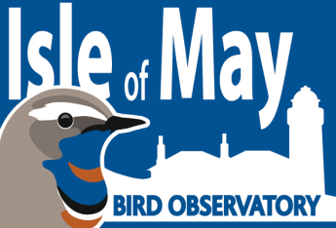
PERSONAL AND CONFIDENTIAL
Young Birders’ Training Course Application Form
Deadline for applications: 5pm, Monday 1st May 2017

If you require additional space to complete any of these questions, please do so by continuing on a new page after the last question rather than alter the format of the application form.
Please make sure it is clearly indicated which question any additional information relates to.

Full Name:

Date of Birth: Sex (please indicate): Male Female

Address:

Telephone
Number(s):

Email
Address:

Are you a member of the SOC, or any other ornithological/conservation organisations? If yes, please provide details in the box below, alongside your involvement with each i.e. regular attendee of local branch talks, contribute to newsletter etc.

Do you have your own optical equipment? If yes, please indicate all which apply:

Binoculars Telescope Tripod

Do you have any allergies or medical conditions that we should be aware of (please refer to guidance notes)? If yes, please provide details in the box below

Where did you first hear about this opportunity?

Describe your birdwatching experience to date (please include details of any previous fieldwork, surveys and volunteer placements undertaken)

What do you understand a bird observatory to be? Please outline briefly below

How do you think you’ll adapt to living in basic, shared hostel-style accommodation where every takes a turn to do the washing up and cleaning with limited access to electricity and only basic washing facilities in your accommodation?

What do you hope to gain from participating in this training course?

Why do you think you should be offered a place on this training course?

If you need to present additional information in answer to any of the above questions, then please create/insert a new page below. Make it clear which question the information relates to.

REFERENCES: Please provide details of two persons we may contact as your personal referees (e.g. lecturer, tutor, neighbour, group leader or colleague). Both referees must be over 18, and must not be a relative of yours, or living at the same address as you.

REFEREE 1:

Full Name:

Address:

Telephone

Number:

Email

Address:

Occupation:

REFEREE 2:

Full Name:

Address:

Telephone

Number:

Email

Address:

Occupation:

I hereby confirm that all the information contained in this application form is correct.

Signed ……………………………………………………………………………..

Date …………………………………………………………………….……….

